Malteurop opens new photovoltaic installation at San Adrian site in Spain

On Wednesday 30 June, Malteurop, one of the world’s leading malt producers, switched on a 12,000 sqm photovoltaic panel installation at its San Adrian malt house in Spain. The facility is located at Malteurop’s Spanish subsidiary, Intermalta. It will cover 12% of the site’s electricity needs and avoid CO₂ emissions of 450,000kg each year.

This launch marks the completion of another initiative demonstrating Malteurop’s commitment to using more renewable energy and shows that the business is fully aligned with VIVESCIA Group’s sustainable development approach.
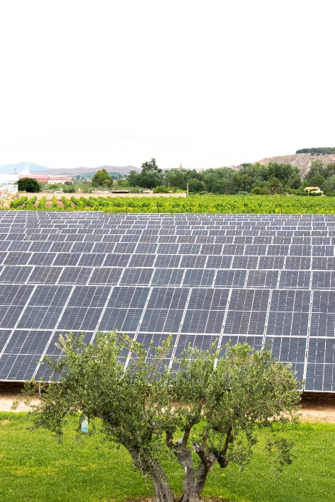
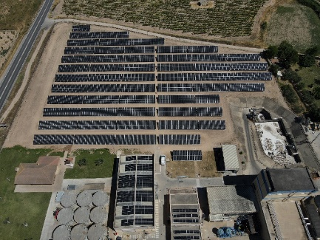

Carbon footprint reduction – a major focus for Malteurop

Producing malt sustainably is Malteurop’s priority. Several years ago, it committed to reducing its environmental impact for the benefit of current and future generations by paying particular attention to its water consumption, its CO₂ emissions, and its carbon footprint from transportation and raw material production. This is a major pillar of M.A.L.T., the Malteurop CSR policy, which provided the impetus for the photovoltaic panel project at the San Adrian site in Spain.

The installation is made up of almost 2,100 panels and covers 12,000 sqm. As well as producing green electricity, it will enable the San Adrian malt house to cut its CO₂ emissions and reduce its electricity bill. The self-generated power produced by this green photovoltaic system will cover around 12% of the plant’s needs.

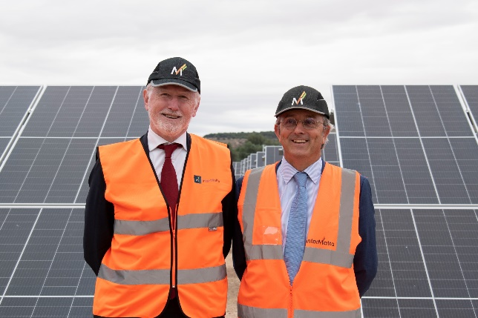
Olivier Hautin, Managing Director of Malteurop and Carlos Alvarez-Fernandez, Managing Director of Intermalta, Malteurop’s Spanish subsidiary, at the switch-on at San Adrian (Spain) on 30 June 2022

“The photovoltaic power facility on the San Adrian site will help us to limit our environmental impact and cut carbon more quickly. This new milestone is concrete evidence of our commitment and other projects are in the pipeline for the coming months and years,” said Olivier Hautin, Managing Director of Malteurop. “On a personal level, I admire the efforts that the teams have put in to achieve this result. I would like to extend my thanks to them for their exemplary commitment and all their hard work,” he continued.




The San Adrian PV panel field – key figures

12,000 sqm available on the site
2,092 modules installed
12% of electricity needs will be covered
Equivalent to the annual electricity consumption of 450 homes
Will avoid carbon emissions of 450,000kg each year

Malteurop accelerates M.A.L.T., its CSR approach

Malteurop launched its CSR policy several years ago as a long-term commitment to a virtuous circle of behaviour. It is paying particular attention to its water consumption, its CO2 emissions, and its carbon footprint from transportation, and from raw material production. It has undertaken numerous initiatives to reduce its carbon footprint and improve energy efficiency. The policies put in place and the efforts of the teams have quickly produced concrete results:

CO2 has already been cut by 17%
against the Group’s target of a 20% reduction by 2025 (versus 2014/2015)
water consumption is already down 27.6%
against the Group’s target of a 25% reduction by 2025 (versus 2014/2015)

This CSR strategy dovetails perfectly with the trajectory set by VIVESCIA Group as a roadmap for all its businesses. VIVESCIA recently unveiled LINK, its new sustainable development strategy, which is to be the motor behind numerous projects across the Group’s various entities. LINK brings a new energy and feeds into the ambition to build long-term, sustainable links with the member-farmers that work the land, the colleagues who take care of the grains and add value to them, clients in the food industry and consumers.

▬▬ About Malteurop - www.malteurop.com

Malteurop, one of the world’s leading malting companies, is a VIVESCIA Group business. As a producer of malts and malted ingredients, it is a recognised barley-malt-beer sector specialist. With close to 1,100 employees across 14 countries, Malteurop is proud of its role in the agricultural sector and the sixty-year history that has seen it grow out of the farming cooperatives of North-East France. It now positions itself as a farmer-maltster serving brewers, distillers and food industry companies.

VIVESCIA is an international, cooperative farming and food processing Group, with 7,000 employees and 60 industrial sites in 24 countries. It generated revenue of €3.1 billion for the year ending 30 June 2021. Specialising in producing and adding value to grain, VIVESCIA is owned by 10,000 farming entrepreneurs from the North-East of France.

Press Contacts

Malteurop - Marie-Jeanne Onfray: marie-jeanne.onfray@malteurop.com
Landline: + 33 3 26 78 61 06 – Mobile: +33 6 76 03 15 36

VIVESCIA Group - Guillaume Fregni: guillaume.fregni@vivescia.com
Mobile: +33 7 72 31 00 18

